**OBLAČILA**

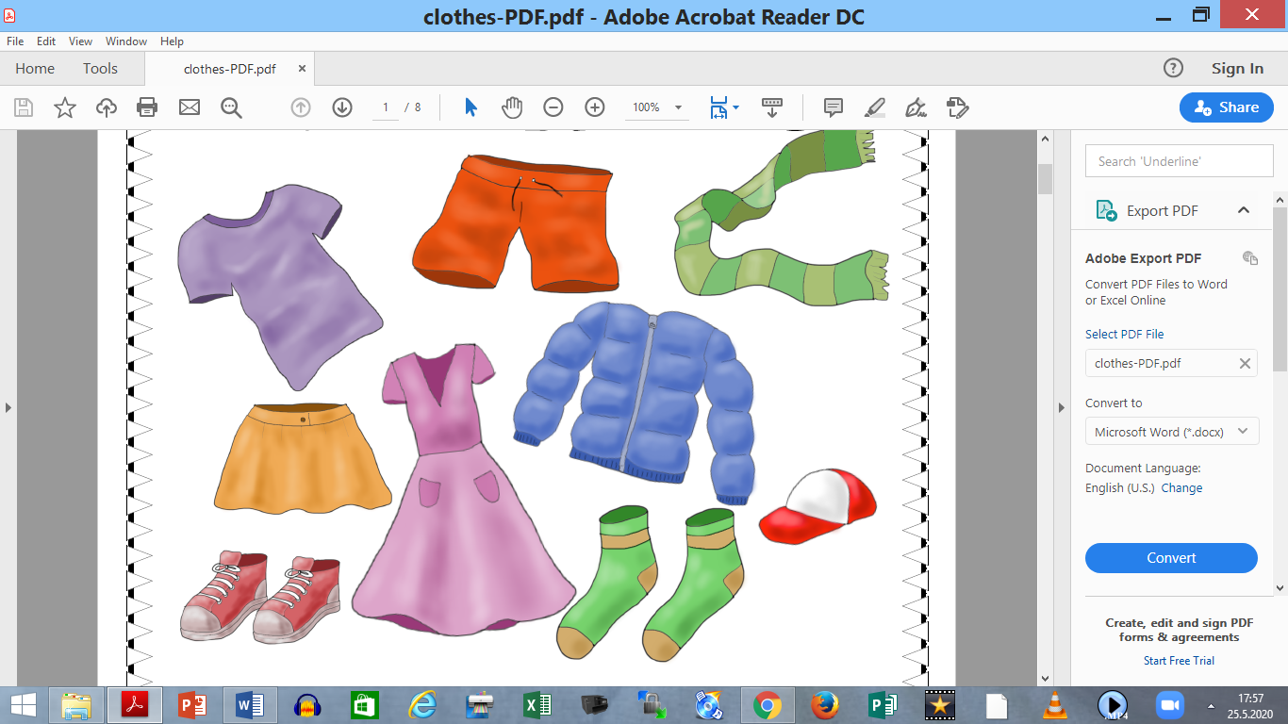

|  |  |
| --- | --- |
|  | **HLAČE** |
|  | **OBLEKA** |
|  | **NOGAVICE** |

|  |  |
| --- | --- |
|  | **KRATKE HLAČE** |
|  | **BUNDA** |
|  | **KRILO** |

|  |  |
| --- | --- |
|  | **KAPA** |
|  | **ČEVLJI** |
|  | **MAJČKA** |

|  |  |
| --- | --- |
|  | **ŠAL** |

**POBARVAJ:**

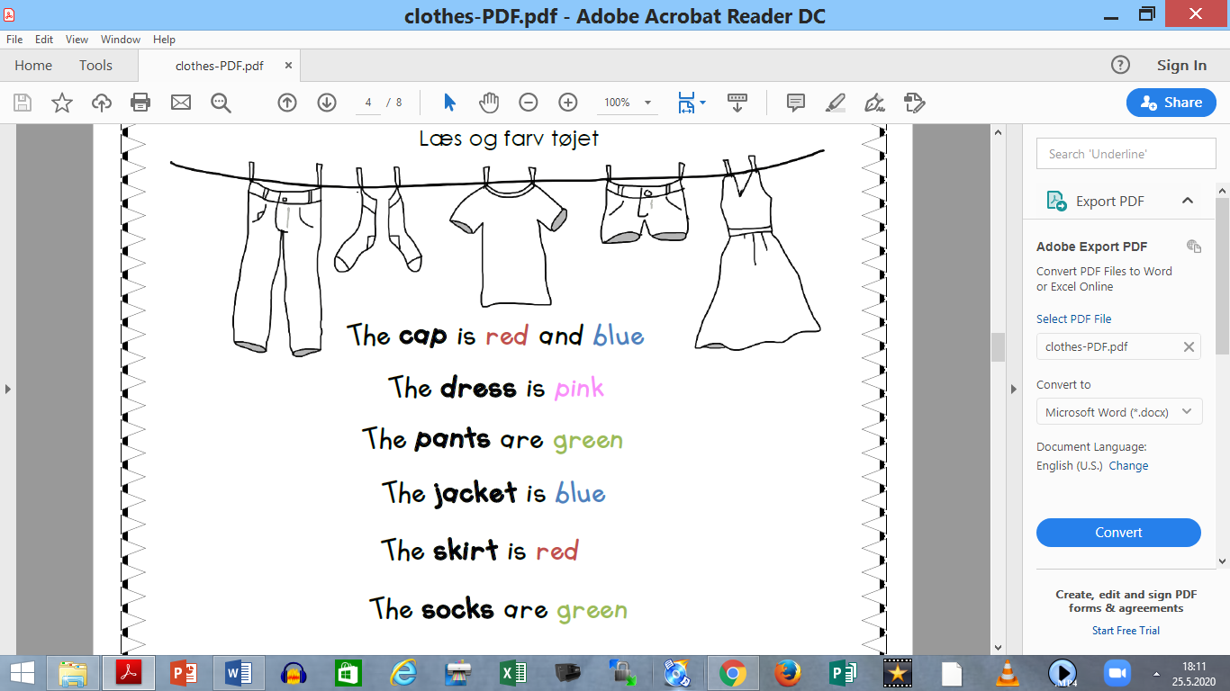

|  |
| --- |
| **KAPA JE MODRE IN RDEČE BARVE.**  **OBLEKA JE VIJOLIČNA.**  **HLAČE SO ZELENE.**  **BUNDA JE MODRA.**  **KRILO JE RDEČE.**  **NOGAVICE SO ZELENE.**  **ČEVLJI SO RJAVI.**  **ŠAL JE ZELEN IN RUMEN.**  **KRATKE HLAČE SO MODRE.**  **MAJČKA JE ORANŽNA.** |

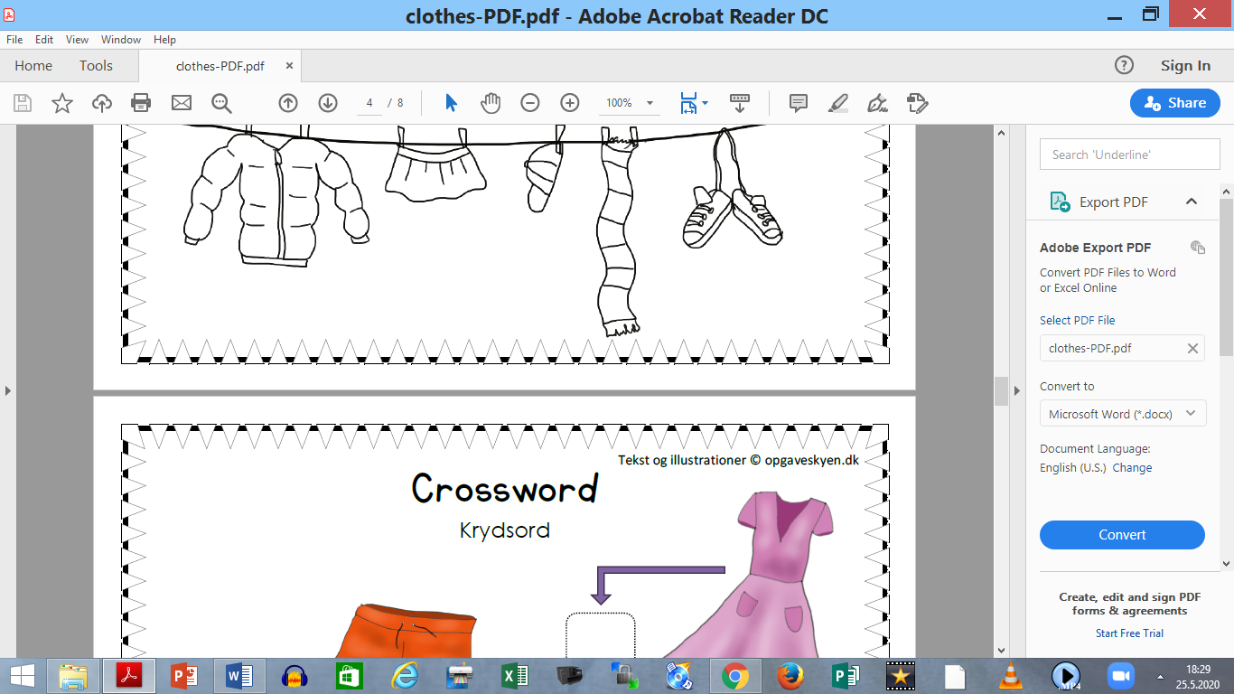

**IZREŽI IN IŠČI PARE**

|  |  |
| --- | --- |
|  |  |
|  |  |
|  |  |

|  |  |
| --- | --- |
|  |  |
|  |  |
|  |  |

|  |  |
| --- | --- |
|  |  |
|  |  |
|  |  |